|  |  |  |  |  |  |  |  |  |
| --- | --- | --- | --- | --- | --- | --- | --- | --- |
| |  | | --- | | Exascend V30 Catalyst 256GB SD Memory Card | | Product image thumb |  |  |  |  |  | | --- | --- | --- | --- | | Product image thumb | Product image thumb | Product image thumb |  | |  | **Featured information:**   * Withstands temperatures from -13 to 149°F * Resistant to impacts from X-rays, magnets and temperature * Water, dust and impact resistant * 256GB storage capacity * Maximum sequential read speed: 180 MB/s   **Price: 40$**  **Specifications:**   * **Capacity:** 256 GB * **Read speed:** 180 MB/s * **Write speed:** 150 MB/s |

**Description:**

#### **Exascend V30 Catalyst 256GB SD Memory Card**

SExascend 256GB UHS-I SDXC is a high-end memory card line with large capacity, read speed of 180 MB/s and write speed of 150 MB/s. Designed specifically for professional photography and videography, this card ensures fast image capture and fast data storage.

#### **Design of Sony RX 100 Mark VII**

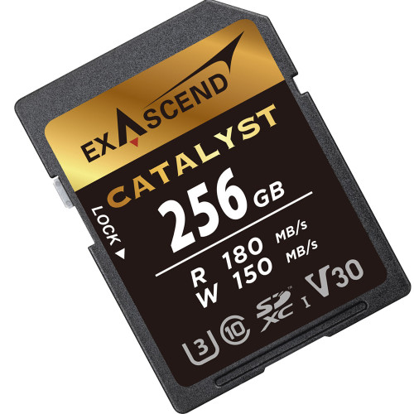

Exascend's memory card line can withstand extremely harsh weather with temperatures ranging from -25 to 85°C, helping users confidently approach the most difficult scenes and create great photos. In addition, Exascend's UHS-I SDXC Card is also waterproof, dustproof, resistant to strong impacts and is safely protected from X-rays and magnets.

